# Signing out of a Citrix Session

Below are instructions on how to sign out of a Citrix session. Please follow this method of signing out instead of simply disconnecting from a session or leaving it connected when you shutdown PC. Signing out assures that all apps are closed down properly, and it prevents issues where a session hangs and you cannot log back in. **Save** any work before doing this.

While you are logged into a Citrix remote machine click on the down arrow in the top middle of the Citrix screen.



Then Click on Ctrl + Alt + Del

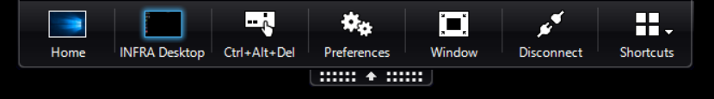

Then click on **Sign Out**

